**LAMBDAS**

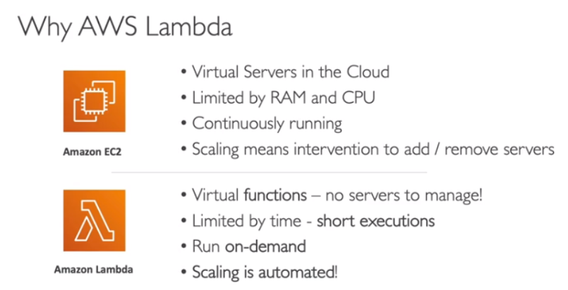

**AWS Lambda is a reactive service which only gets invoked upon request.**

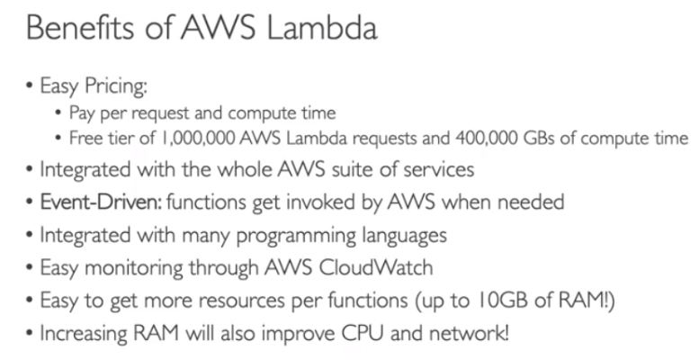

**AWS LAMBDA LANGUAGE SUPPORT:**

* Node.js (JavaScript)
* Python
* Java (Java 8 compatible)
* C# (.NET Core)
* Golang
* C#/Powershell
* Ruby
* Custom Runtime API (community supported)

**Lambda Container Image:**

* The container image must implement the Lambda Runtime API. There are very specific docker images that can run on lambdas.
* ECS/Fargate is preferred for running arbitrary docker images

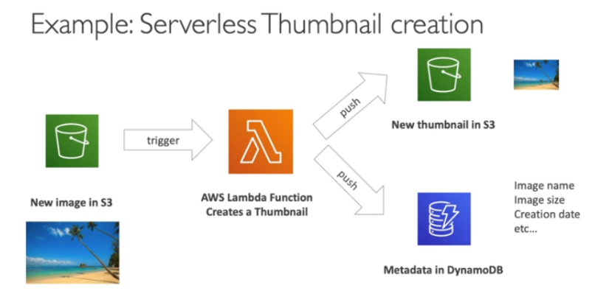

**CRON JOB:** A job that is scheduled for every hour, every day. By default, a cron job is run on a Linux AMI.

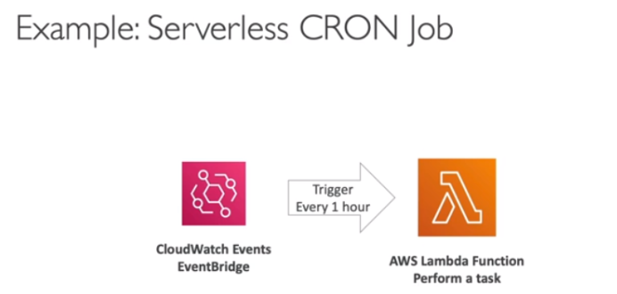

**AWS Lambda Pricing:**

* Pricing at: <https://aws.amazon.com/lambda/pricing>
* Pay per calls:
* First 1,000,000 (1 million) requests are free
* $0.2 per 1 million requests thereafter ($0.0000002 per request)
* Pay per duration: (in increment of 1 ms)
* 400,000 GB-secs of compute time per month if FREE
* ==400,000 seconds if function is 1 GB RAM
* ==3,200,000 seconds if function is 128MB RAM
* After that, $1.00 for 600,000 GB-secs
* It is usually very cheap to run AWS Lambda so it is very popular

**NOTE:** Lambda pricing is based on calls and duration.

**AWS Lambda Hands-On**

* AWS Lambda lets you run code without thinking about servers
* It gives us the configuration of lambda on the ‘begin’ page
* If there is more load, lambda will automatically scale-up